**Students Attendance Management System**

**A Project On**

“STUDENTS ATTENDANCE MANAGEMENT SYSTEM”



Submitted in Partial fulfillment of

Requirement for the Diploma

of

Computer Science

**Submitted to**

**Govt. Polytechnic College Katni (M.P.)**

**Submitted by** :-

KARUNA DEVI PATEL - 12114C04023

ABHINANDAN YADAV - 15114C04002

AKASH SONI - 15114C04006

POORNIMA MISHRA - 15114C04034

**Under The Guidance :-**

**Mr. Sudhir Kumar**



**CERTIFICATE**

This is to certify that, student of katni polytechnic college has completed the project of computer science in 6th semester entitled “STUDENTS ATTENDANCE MANAGEMENT SYSTEM”. We have submitted this project in partial fulfillment of the diploma in computer science from Rajiv Gandhi Proudyogiki Vishwavidyalaya, Bhopal (M.P.) for year 2018.

The matter embodied in this project work has not been submitted earlier for award of any degree to the best of my knowledge and belief.

**GOVT. POLYTECHNIC COLLEGE KATNI (M.P.)**

**Principal Guidance By H.O.D.**

**Dr.M.S.C.Ujjir Mr.Sudhir Kumar Dr.N.Varkhedkar**

**GOVT. POLYTECHNIC COLLEGE**

**KATNI (M.P.)**



**SELF CERTIFICATE**

This is to certify that the project report entitled **“Students Attendance Management System”** is done by me is an authentic work carried out for the partial fulfillment of requirement for the award of the Diploma in Computer Science it the **Rajiv Gandhi Proudyogiki Vishwavidyalaya, Bhopal** under the guidance of **Mr. Sudhir Kumar** The matter embodied in the project work not been submitted earlier for award of any degree or diploma to the best of my knowledge and belief.

**EXTERNAL EXAMINER INTERNAL EXAMINER**

**GOVT. POLYTECHNIC COLLEGE**

**KATNI (M.P.)**



**Declaration**

We hereby declare that **this “STUDENTS ATTENDANCE MANAGEMENT SYSTEM”** has been developed by us adhering to the condition laid down by the **Rajiv Gandhi Proudyogiki Vishwavidyalaya, Bhopal** under the guidance of **Mr. Shudhir Kumar.**

Karuna Devi Patel (12114C04023)

Abhinandan Yadav (15114C04002)

Akash Soni (15114C04006)

Poornima Mishra (15114C04034)

**Acknowledgement**

We have great pleasure in expressing our deep sense of gratitude to our guide **Mr. Sudhir Kumar** for their valuable guidance and remarkable suggestion in completing our software project on **“STUDENTS ATTENDANCE MANAGEMENT SYSTEM”** It is due to their encouragement and persistent motivation that we could extend the project too much data processing.

We would like to take this opportunity to express our sincere thanks and Deep sense of gratitude to our teachers, friends and well wishes that have helped us in some way or the other for completion of the project.

**Project Team**

**Karuna Devi Patel 12114C04023**

**Abhinandan Yadav 15114C04002**

**Akash Soni 15114C04006**

**Poornima Mishra 15114C04034**

**TABLE OF CONTENT**

Acknowledgement……………………………………………..…………………iv

***Chapter 1***

***About Software*…………………………………………………………………. 01**

* 1. Introduction
  2. Starting Operation
  3. User Management
     1. HOI
     2. FACULTIES
     3. STUDENT

***Chapter 2***

***Hardware and Software Specification ……………….…………………………04***

***Chapter 3***

***Table Structure………………………………………………….……………….05***

***Chapter 4***

***Software System Design…………………………………………………………12***

***Chapter 5***

***About PHP …………………………………………………….…..……………24***

***Chapter 6***

***MySQL …………………………………………………………..………………25***

***Chapter 7***

***Screenshots ……………………………………………………..………………26***

***Reference………………………………………………………..………………55***

**List of diagram**

1. **DFD ……………………………………………………….……12**
2. **ER Diagrams ……………………………………………..……15**
3. **Use Case Diagrams……………………………………….……16**
4. **Navigation Diagram………………………………………..…..19**
5. **Incremental Model………………………………………….….20**

***Chapter 1***

***About Software***

**1.1 Introduction:-**

The project students attendance management system is a software package developed for managing student’s attendance details, branch details, faculty details, teaching details, students profile details and college details. The software is very helpful to find the eligible candidates for the attendance from different branch and subject in a college. The project finds the eligible candidates (students) from students list on the basis of branch code, subject code and semester.

The project is developed for students attendance managements of a college. At the time of student giving application the teacher can add data with regards to the student’s name, roll number , branch, category etc concerned with attendance .

Institutions once can very well sort out eligible student for attendance. The campus information system here developing will help to get up to date information of a student regarding his both academic and non-academic activities.

Through the system we can easily maintain the data without any loss or damage. By using this system time consumption will be reduced. By using this website, faculty can easily know about the information of student attendance details. Faculty staff officer can easily check the eligible for the attendance. Faculty staff officer maintain the each and every student details.

**1.2 Starting operations**: -

Institution homepage, where presents various fields there clicked by the user and login .Log-in by using the institute/faculty/HOI/parent/students user ID and password provided to them by department.

User has to click on the “Login” from the menu, displayed on the related page. Then enter ID, password and click on Login. On all correct entries for login, the welcome page.

* 1. **User Management**: -

This option facilitates users to change their authentication password at any moments. Users may do so by clicking “change password”. To ensure misuse of unsupervised opened session we have asked user to enter the current password as well along with new password (two times) and then click on “change password” button.

1. **HOI : -**

This option can be used for

* Registration of institute profile, schema wise bank account details of the institute, course run by institute, course wise fee structure.
* To update the bank details and mobile number of the college.

1. *Institute Profile Registration: -*details the rgpv officer for Registration, Institute addresses and contact number are to be registered.
2. *Bank Account Registration:*- for each of the post-matric scheme (SC, ST, OBC), institute has to registered the bank account Details.
3. *Registration of Course: -*all the courses run by the institute should be registered to enable the student to select the course at the time of online registration.
4. *Updating of course fee:-*To updating the registered course fee, institute can use this option.
5. *Edit –lock -Print Application:-*For updating the application details, user has select “Edit/Lock print” option and the click on “Edit Application” for the application to be edited.
6. *Upload Institute Photo:-* Institute has to make use of this option to upload one photograph of the institute to the portal, which will be displayed in the institute home page of the student attendance portals.
7. **Faculty Registration:-**

Registration of faculty is to be done by the HOI for each course and branches, registered with the institute. This will help the institute for assignment of different subject at the session of processing of student attendance management for submission of attendance.

1. **HOI Registration :-**

Registration of new HOI is to done by the present current HOI for use each activities are also defined previous heading.

# Faculties :-

# This option can be used by the faculties for “ATTENDANCE , ADD CLASS, ADD STUDENT , VIEW ATTENDANCE , VERIFY STUDENTS PROFILE “.

1. ATTENDANCE :-

Registered faculties are used this feature for fill-up students attendance .

1. ADD CLASS :-

This feature used for add new class in a particular branch and semester. This class is used for teaching in current session.

1. ADD STUDENT :-

This field is used to add a new student in database for various subject attendance.

1. VIEW ATTENDANCE :-

This is used for view attendance to all students that is particular subject and branch between entered two dates.

1. VERIFY STUDENTS :-

Registered faculties are used this feature for verify students profile and add this students database for the purpose attendance that request is requested by the students. This field faculty is used three option add, view and delete. Delete option can be used for delete to request.

1. **Students :-**

This option can be used by the student for the fill student profile form and view our attendance.

* 1. **Fill Student Profile Form :**-

In this field student fill all details and submit request to the teacher. When the teacher request is accepted then student user login is created.

* 1. **View Attendance :**-

In this field student view only our attendance.

1. **Person :**-

This option can be used by the student parent’s for the view attendance.

***Chapter2***

***Hardware and Software Specification***

**2.1Minimum hardware requirement:-**

1. Microprocessor Intel Pentium (1G.Hz.)
2. Primary storage (RAM) -256MB
3. Secondary storage (Hard Disk) -40GB
4. Pan drive for software installation
5. Display device (monitor).
6. Keyboard
7. Mouse

**2.2Software requirement for clients:-**

1. Operating System window XP (Professional)
2. MySQL 2000 or above
3. Firefox /Chrome

**2.3Software requirement for server:-**

1. Operating System window XP (Professional)
2. WAMP server
3. MySQL 2000 or above
4. Firefox /Chrome

Chapter3

***Table Structure***

1. **College :-**

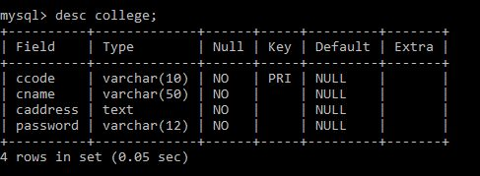

**Fig 3.1**  Store College details.

1. **Branch :-**

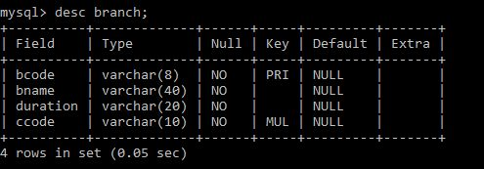

**Fig 3.2**  Store Branch details .

1. **HOI :-**

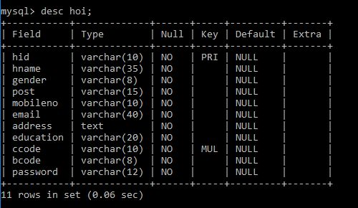

**Fig 3.3**  Store Higher Department Details .

1. **HOItemp :-**

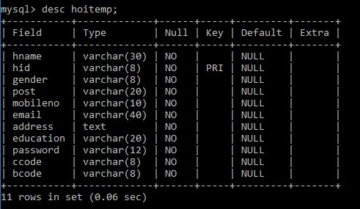

**Fig 3.4** Store Higher Department Details Temporary.

1. **Faculty :-**

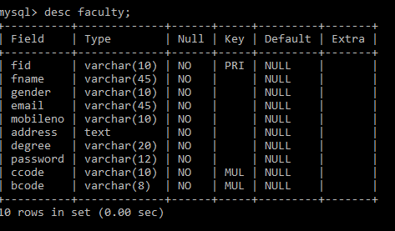

**Fig 3.5**  Sotre Faculty Details .

1. **Facultytemp :-**

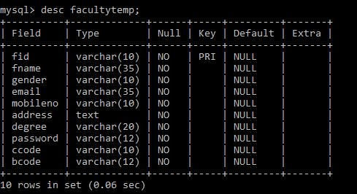

**Fig 3.6** Store Faculty Details for Temporary.

1. **Student :-**

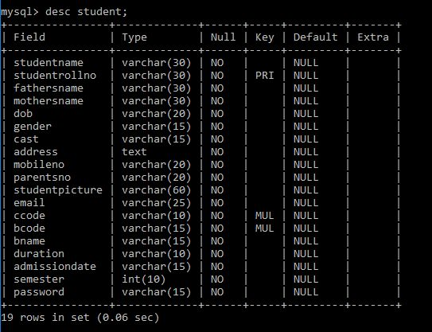

**Fig 3.7**  Stored Students Details.

1. **Studenttemp :-**

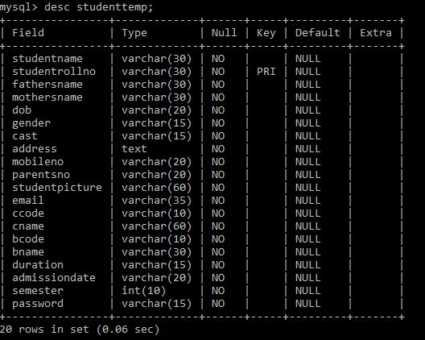

**Fig 3.8**  Stored Students Details For Temporary.

1. **Person :-**

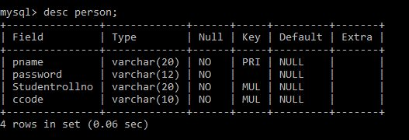

1. **Subject :-**

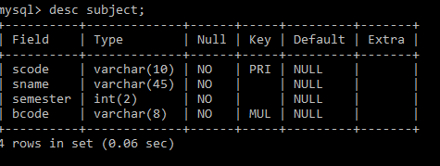

**Fig 3.10**  Stored Subjects Details.

1. **Studentsubject :-**

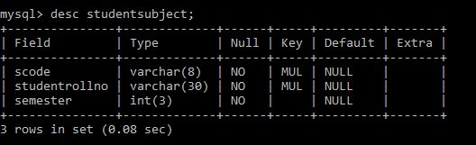

**Fig 3.11**  Stored Relationship Between Students and Subject .

1. **Teaching :-**

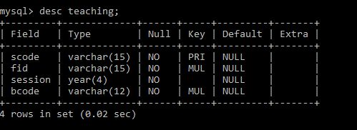

**Fig 3.12**  Stored Teaching Details.

1. **Attendance :-**

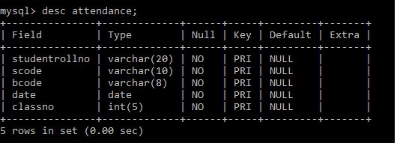

**Fig 3.13**  Stored Students Attendance.

***Chapter4***

***Software System Design***

***4.1 DFD (Data Flow Diagram):-***

A DFD Is the graphical representation that depicts information flow and the transforms that are applied as data move from input or output. The DFD may be used to represent a system or software to any level of abstraction DFDS may be partitions into levels that represent increasing information flow and functional details. The DFD provide a mechanism for functional modeling as well as information flow modeling Similarly DFD level1 can be refined into next level2.The information flow continuity has been maintained between each level.

The refinement of DFD’S continuing until each bubble performs a simple function until the process represent by the bubble performs a functions that would be easily implemented as a program component.

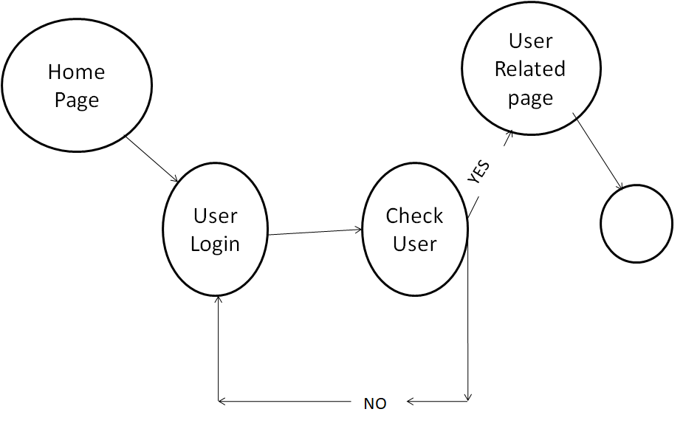

***Fig 4.1***

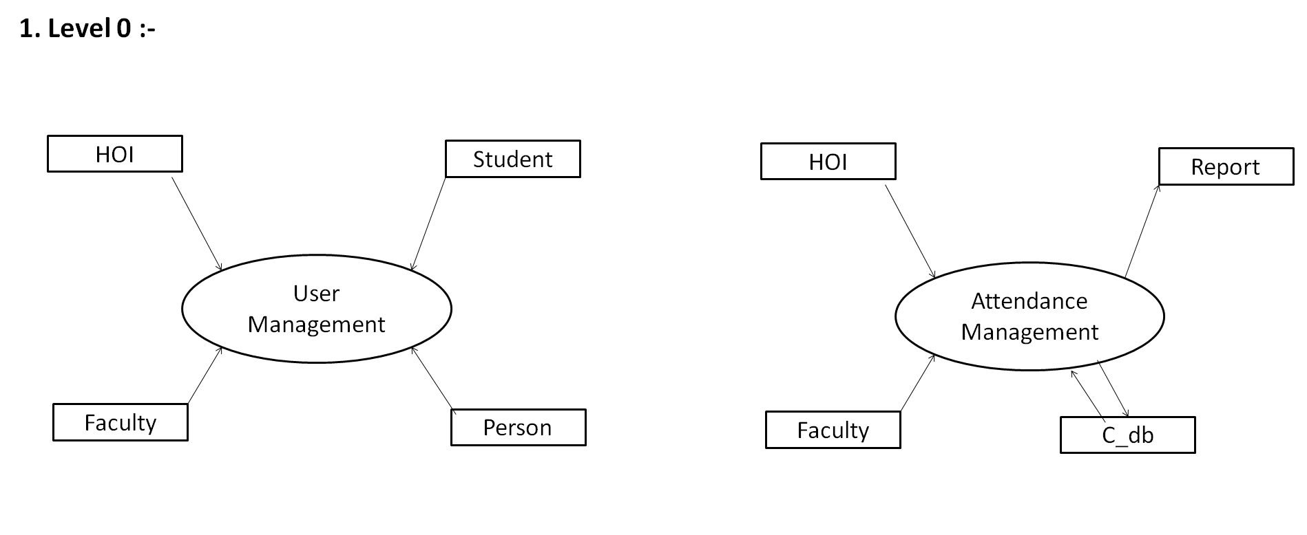

**Fig 4.2**

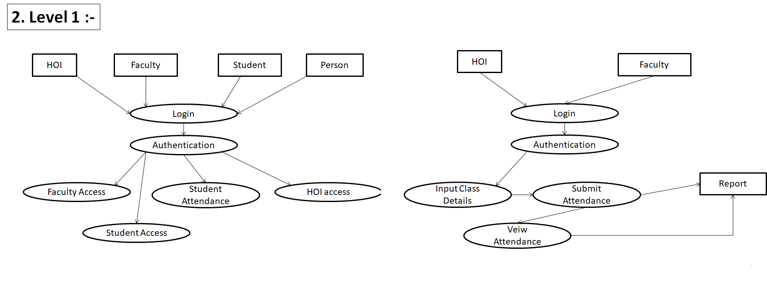

***Fig 4.3***

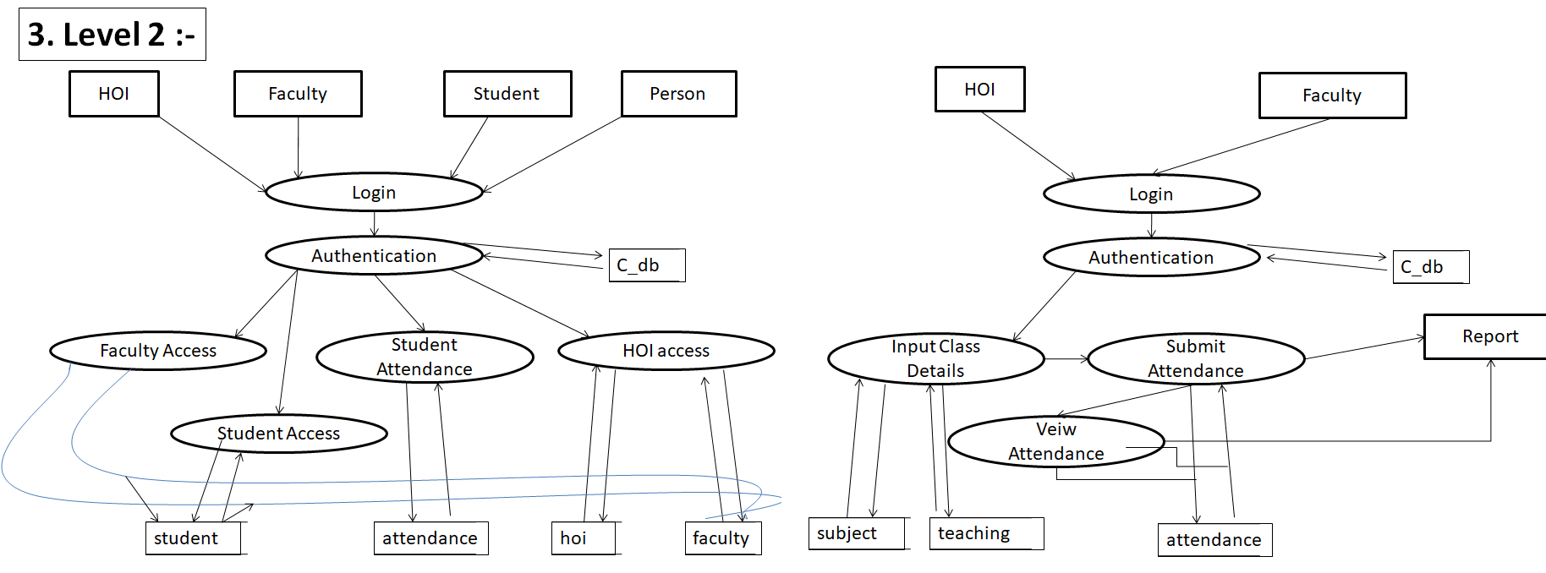

***Fig 4.4***

* 1. ***E-R Diagram :-***

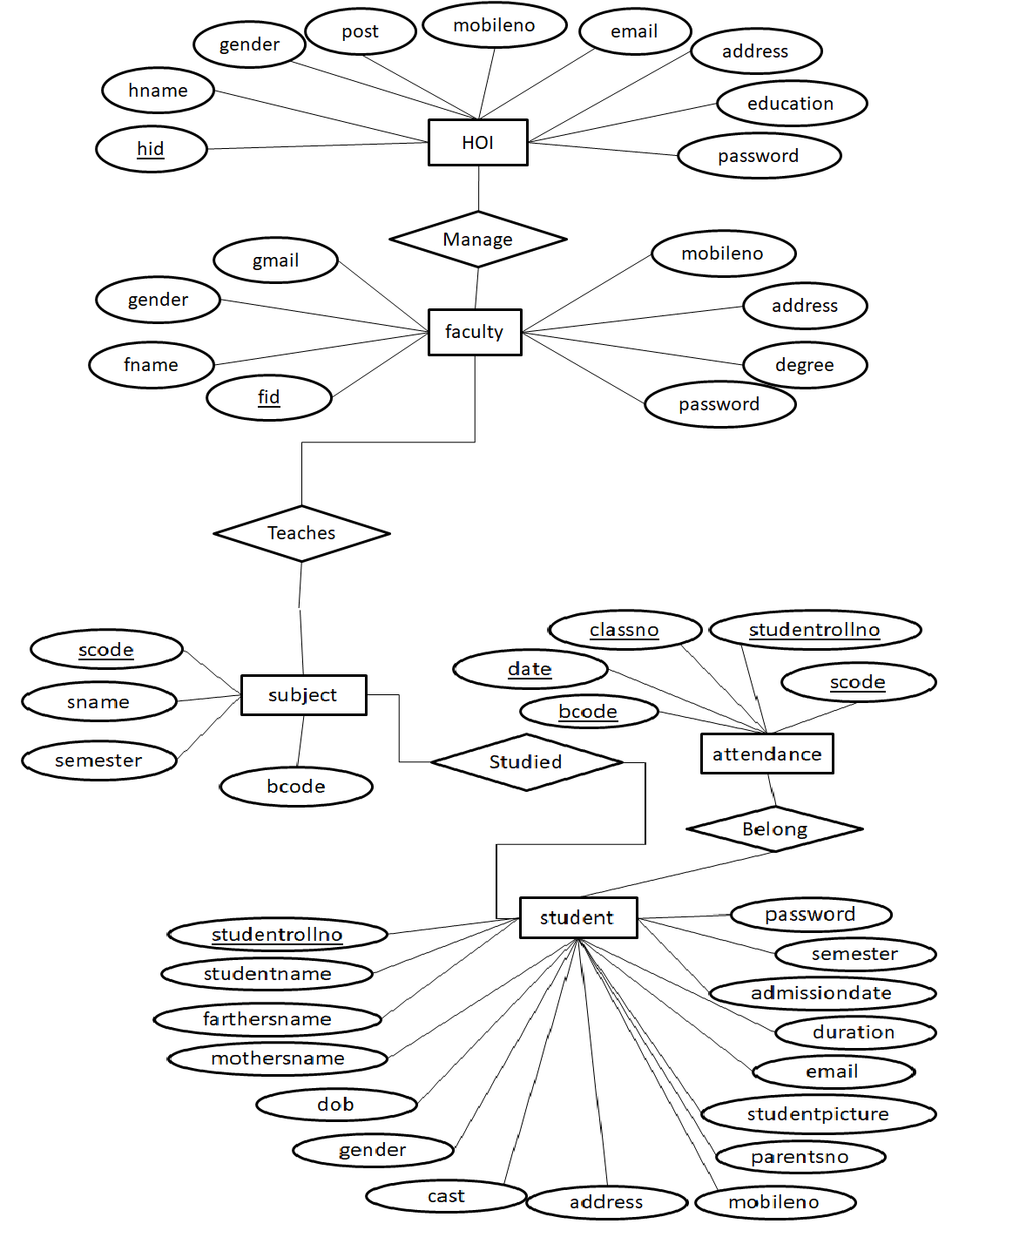

***Fig 4.5***

***4.3 Use Case Diagram :-***

***Use Case Diagram 1***

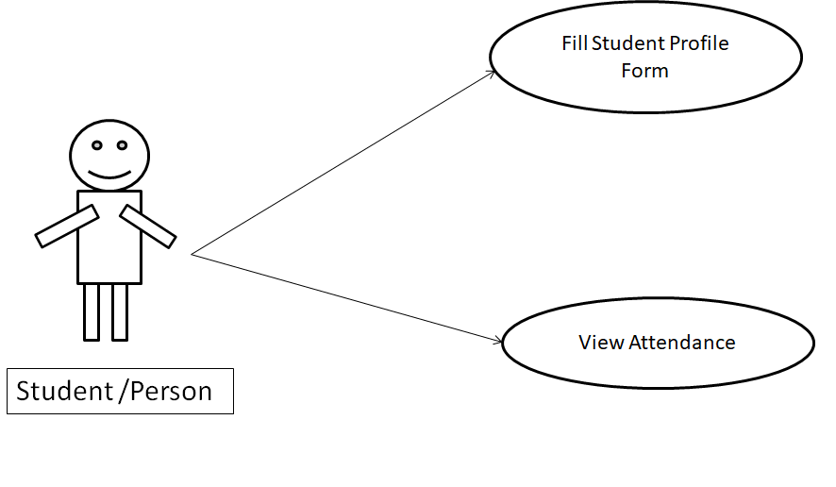

Fig 4.3

***Use Case Diagram 2***

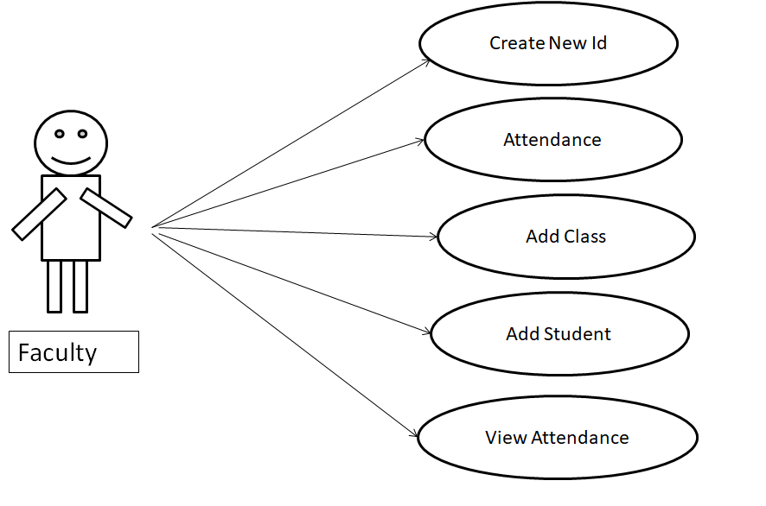

***Fig 4.4***

***Use Case Diagram 3***

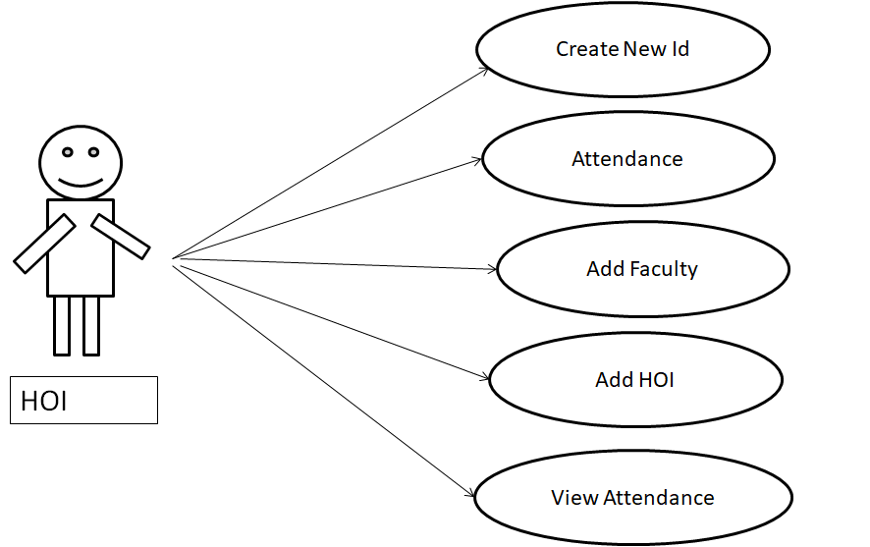

***Fig 4.4***

* 1. ***Navigation Diagram :-***

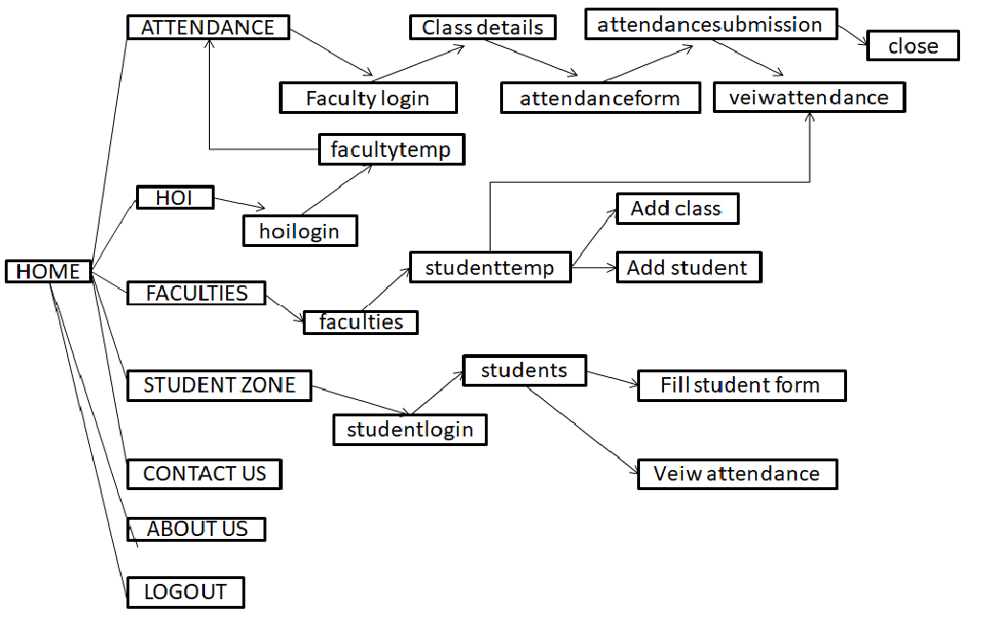

***4.5 The incremental model:*** The incremental model combines the element of the linear sequential model with the iterative philosophy of prototyping. When incremental model is used the first incremental often is core product. This process is repeated following the delivery of each incremental of until the complete product is produced.

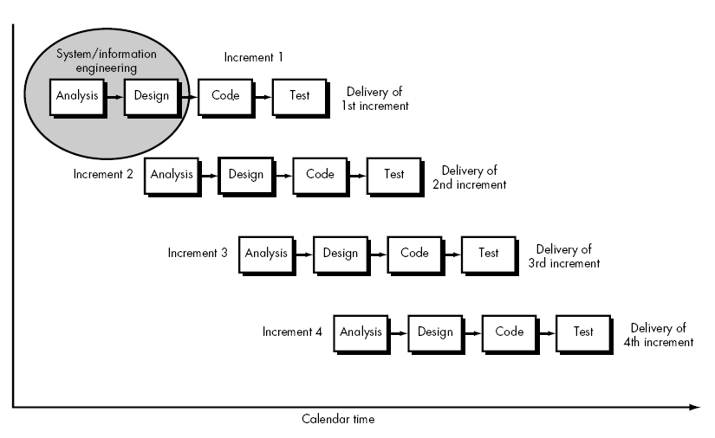

Fig 4.6

In incremental model the whole requirement is divided into various builds. Multiple development cycles take place here, making the life cycle a “multi-waterfall” Cycle. Cycles are divided up into smaller, more easily managed modules. Incremental model is a type of software development model like V-model, Agile model etc.

This model can be used when the requirements of the complete system are clearly defined and understood. Major requirements must be defined; however, some details can evolve with time. There is a need to get a product to the market early. A new technology is being used Resources with needed skill set are not available There are some high risk features and goals.

Some other models that you must read about: In this model, each module passes through the requirements, design, and implementation and testing phases. A working version of software is produced during the first module, so you have working software early on during the software life cycle. Each subsequent release of the module adds function to the previous release.

**4.6 *Analysis :-***Analysis is a detailed study of the various operations performs by a system and their relationship within & outside of system. The analysis is defining the boundaries of the system & determining whether or not a candidate system should consider other related system. During analysis, data are collected on the available. File decision points and transaction handled by the present system.

A key question is what must be done to solve the problem during analysis data are collected on the available file, decision points, & transaction handled by the present system. We visit the various internet sites for knowing the working of messenger, what facilities they provides to users such as send instant message, send a file, send a photos etc. after that we implement database using those information & use this database in our project.

***4.7 Feasibility Study*** :-Evaluation of existing system and procedures analysis of alternative candidate system. Feasibility study is a test of proposal according to its workability, impact on the organization, ability to meet user needs & effective use of resources. It must answer three key questions: Is there a new & better way to do the job that will benefit the user?

What are the costs & savings of the alternative?

What is recommended?

These Questions resolve around investigations & evaluation of the problem identification & description of candidate system specifications of performance & the cost of each system & final selection of the best system. The most successful system project is not necessarily the biggest or most visible in a business but rather those that truly meet user expectations. More project fail because of inflated expectations then for any other reason.

Steps in facilities Analysis:-

* Form a project team & appoint a project leader.
* Prepare system flowcharts.
* Enumerate potential candidate systems.
* Describe & identify characteristics of candidate systems.
* Determine & evaluate perform & cost effectiveness of each candidate systems.
* Weight system performance & cost data.
* Select the best candidate system.
* Prepare & report final project directive management.

***4.8 Design :-***

The purpose of the design phase is to plan a solution of the problem specified by the requirement document .This phase is the first step in moving from the problem domain to the solution domain . Starting with what is needed; design takes us toward how to satisfy the needs.

The design affects the quality of the software; it has major impact on the later phase, particularly testing and maintenance .the output of this phase is the design document. This document is similar to a blue print or a plan for the solution and is used later during implementation, testing and maintenance

At the end of the system design all the major data structures, file formats, output formats, and the major modules in the system and their specifications are decided.

**4.9 *Coding:-***

Once the design is complete, most of the major decision about the system has been made. The goal of the coding phase is to translate the design of the system into code in a given programming language. For a given design, the aim in this phase is to implement the design in the best possible manner. Phase affects both testing and maintenance effort.

Hence, during coding the focus should be on focus be on developing program that is easy to wire. Simplicity and clarity should be striving for during the coding phase. In each form we use command button to add new record, update existing record, search desire information and display.

***4.10 Debugging :-*** This stage is the discovery and correction of programming errors so that it is engird that the program does what the programmer intends to do and produces the correct results for a set of test data. The tools that can be used to debug program:-

1. Simulators
2. Logic points
3. Trace routine
4. Memory dump
5. Software interrupt

***4.11 Maintenance :-***This stage is the updating and correcting of the program to account for changing condition of field experience proper testing and documentation should significantly reduce the frequency and extent of the required maintenance. The original program may need change for following reason:-

* Newly discovered bugs
* Specification change
* Specification expansion
* New equipment

***Chapter 5***

***About PHP***

**PHP: Hypertext Preprocessor** (or simply **PHP**) is a server-side scripting language designed for web development but also used as a general-purpose programming language. It was originally created by Rasmus Lerdorf in 1994,the PHP reference implementation is now produced by The PHP Group. PHP originally stood for *Personal Home Page*, but it now stands for the recursive acronym *PHP: Hypertext Preprocessor*.

PHP code may be embedded into HTML code, or it can be used in combination with various web template systems, web content management systems, and web frameworks. PHP code is usually processed by a PHP interpreter implemented as a module in the web server or as a Common Gateway Interface (CGI) executable. The web server combines the results of the interpreted and executed PHP code, which may be any type of data, including images, with the generated web page. PHP code may also be executed with a command-line interface (CLI) and can be used to implement standalone graphical applications.

The standard PHP interpreter, powered by the Zend Engine, is free software released under the PHP License. PHP has been widely ported and can be deployed on most web servers on almost every operating system and platform, free of charge.

The PHP language evolved without a written formal specification or standard until 2014, leaving the canonical PHP interpreter as a de facto standard. Since 2014 work has gone on to create a formal PHP specification.

During the 2010s there have been increased efforts towards standardisation and code sharing in PHP applications by projects such as PHP-FIG in the form of PSR-initiatives as well as Composer dependency manager and the Packagist repository. PHP hosts a diverse array of web frameworks requiring framework-specific knowledge, with Laravel recently emerging as a popular option by incorporating ideas made popular from other competing non-PHP web frameworks, like Ruby on Rails.

***Chapter6***

***About MySQL***

**MySQL** (officially pronounced as /maɪ ˌɛskjuːˈɛl/ "My S-Q-L",) is an open-source relational database management system (RDBMS). Its name is a combination of "My", the name of co-founder Michael Widenius's daughter, and "SQL", the abbreviation for Structured Query Language. The MySQL development project has made its source code available under the terms of the GNU General Publi License, as well as under a variety of proprietary agreements. MySQL was owned and sponsored by a single for-profit firm, the Swedish company MySQL AB, now owned by Oracle Corporation. For proprietary use, several paid editions are available, and offer additional functionality.

MySQL is a central component of the LAMP open-source web application software stack (and other "AMP" stacks). LAMP is an acronym for "Linux, Apache, MySQL, Perl/PHP/Python". Applications that use the MySQL database include: TYPO3, MODx, Joomla, WordPress, Simple Machines Forum, phpBB, MyBB, and Drupal. MySQL is also used in many high-profile, large-scale websites, including Google (though not for searches), Facebook, Twitter, Flickr, and YouTube.

***Chapter 7***

***Screenshots***

HomePage 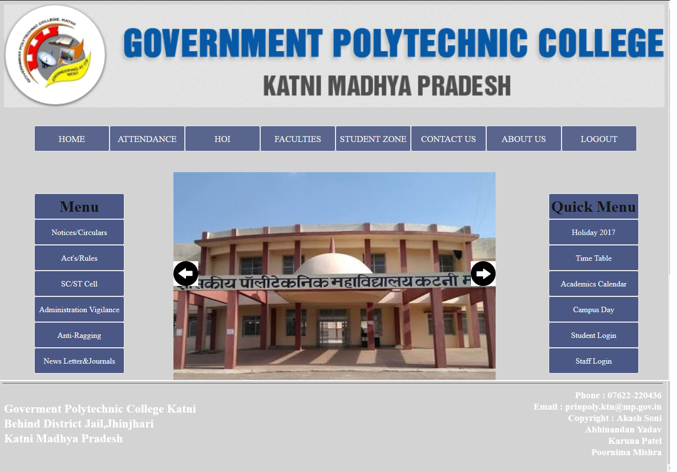

Fig 10.1

This is HomePage.

**1st User Login**

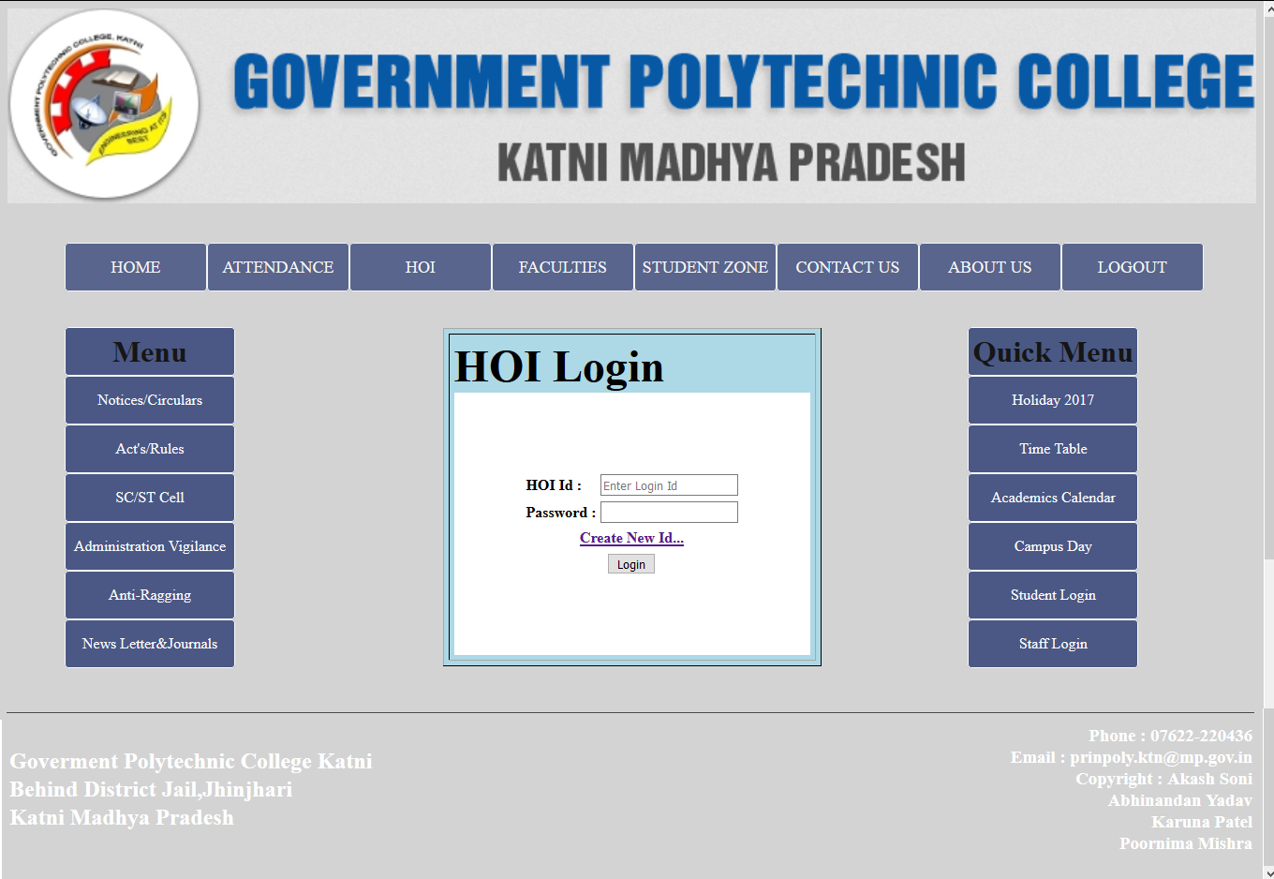

**Fig 10.2**

Higher Department log-in by using the user ID and password provided to them by department.

User has to click on the “ Login” from the menu, displayed on the relative page. Then enter ID, password and click on Login. On all correct entries for login, the welcome page of Student attendance portal .

. 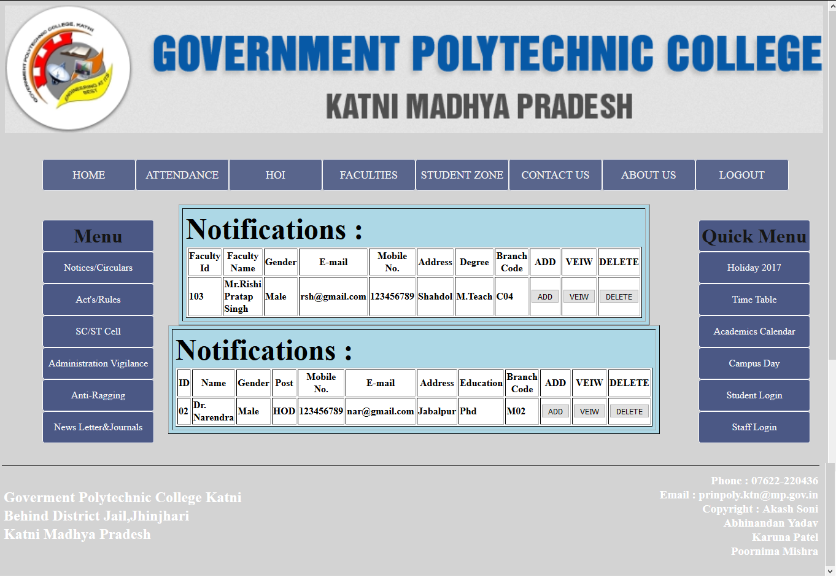

Fig 10.3 User has to click on the “ Login” from the menu, displayed on the thispage

2nd User Login

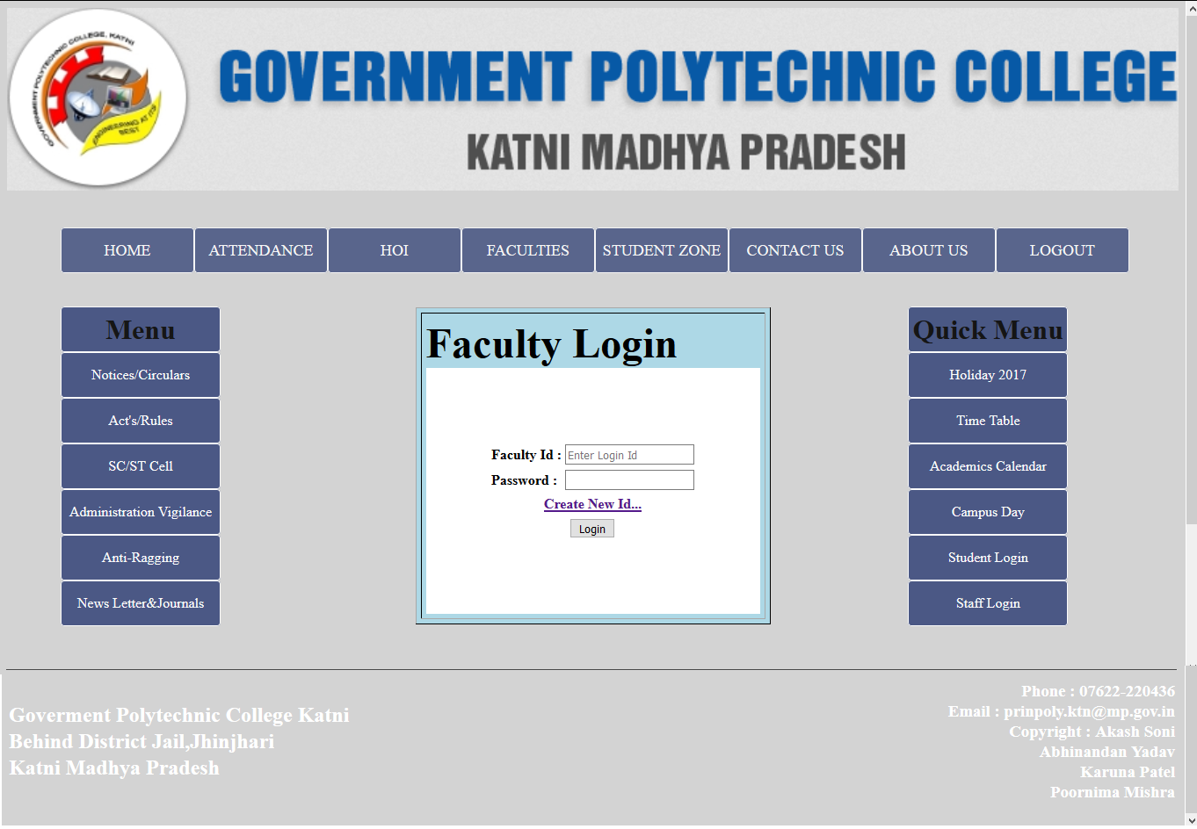

Fig 10.4

Faculty log-in by using the user ID and password provided to them by department.

User has to click on the “ Login” from the menu, displayed on the relative page. Then enter ID, password and click on Login. On all correct entries for login, the welcome page of Student attendance portal .

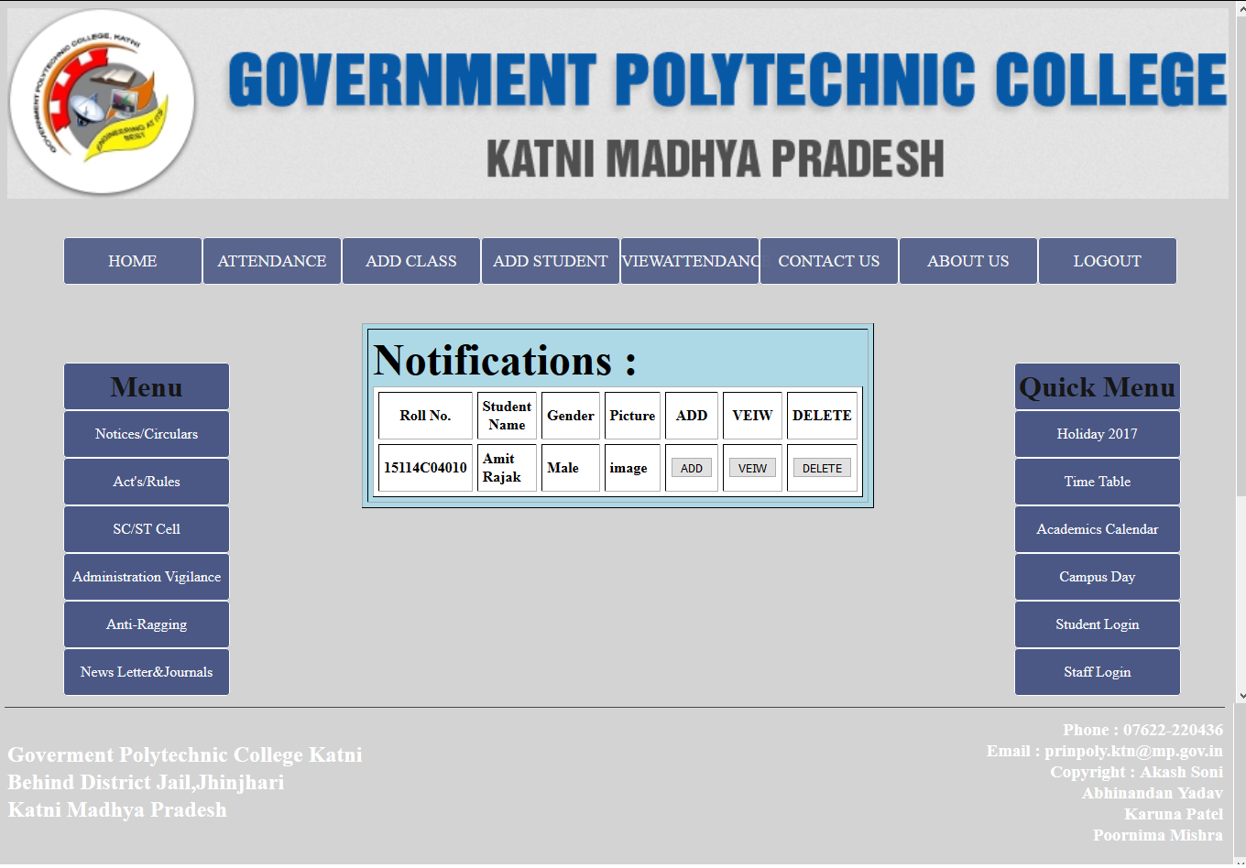

Fig 10.5

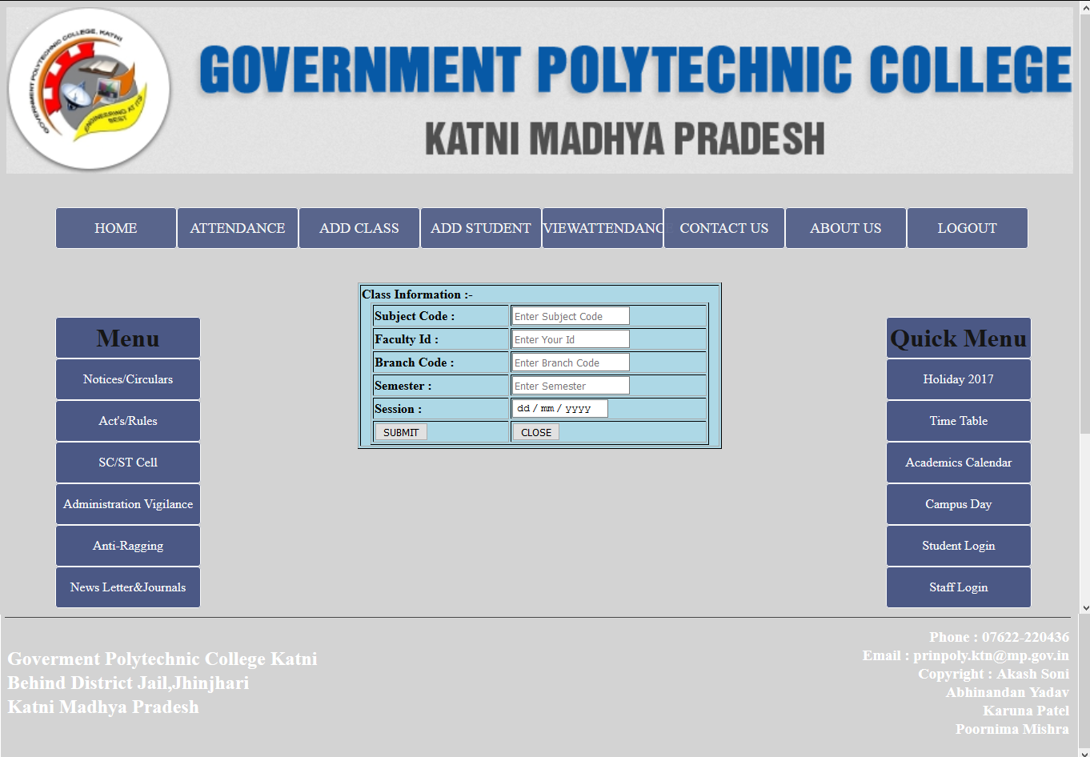

Fig 10.6

3rd Login For The Attendance

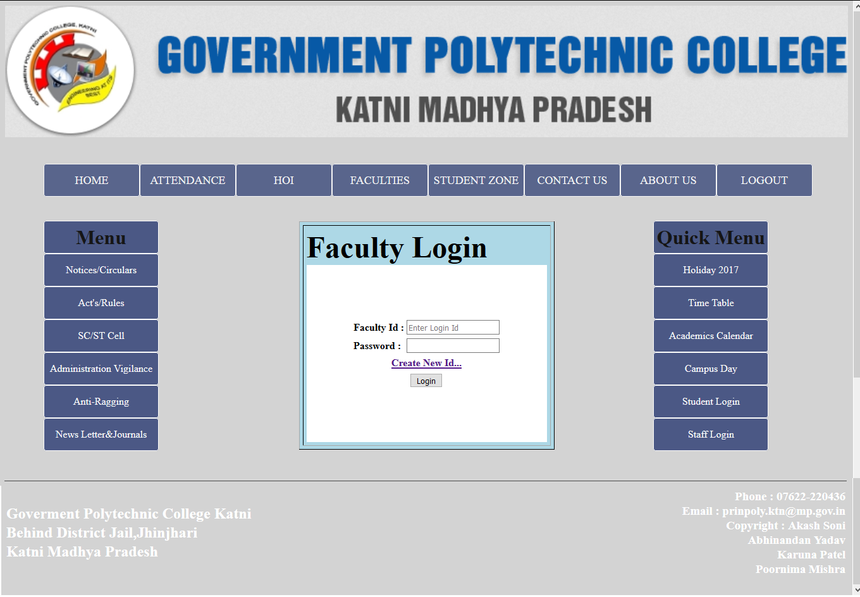

Fig 10.7

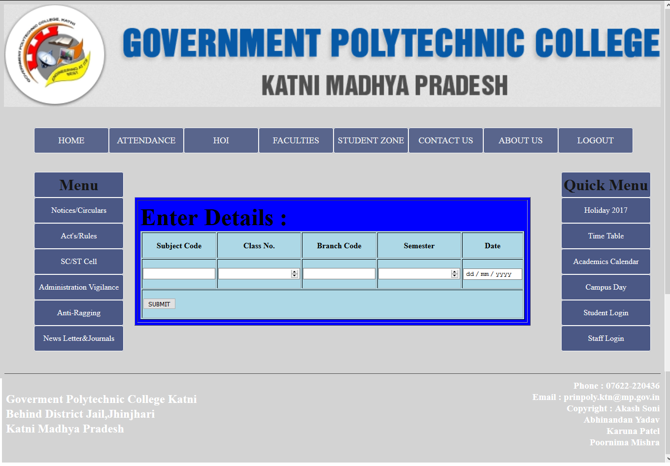

Fig 10.8

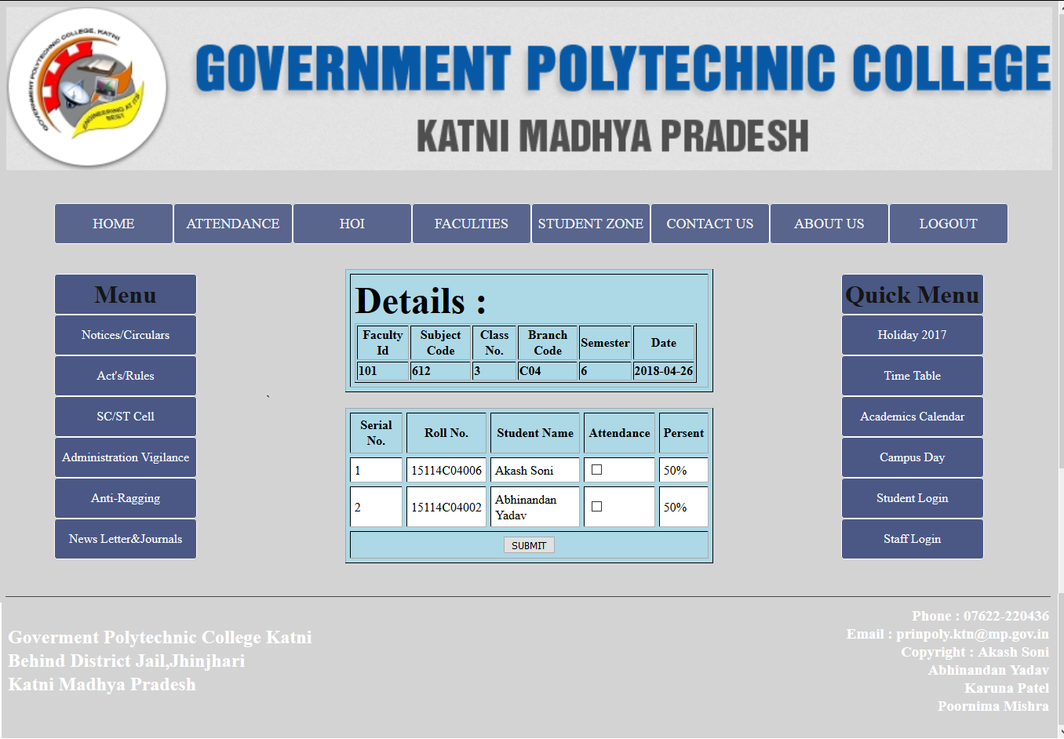

Fig 10.9

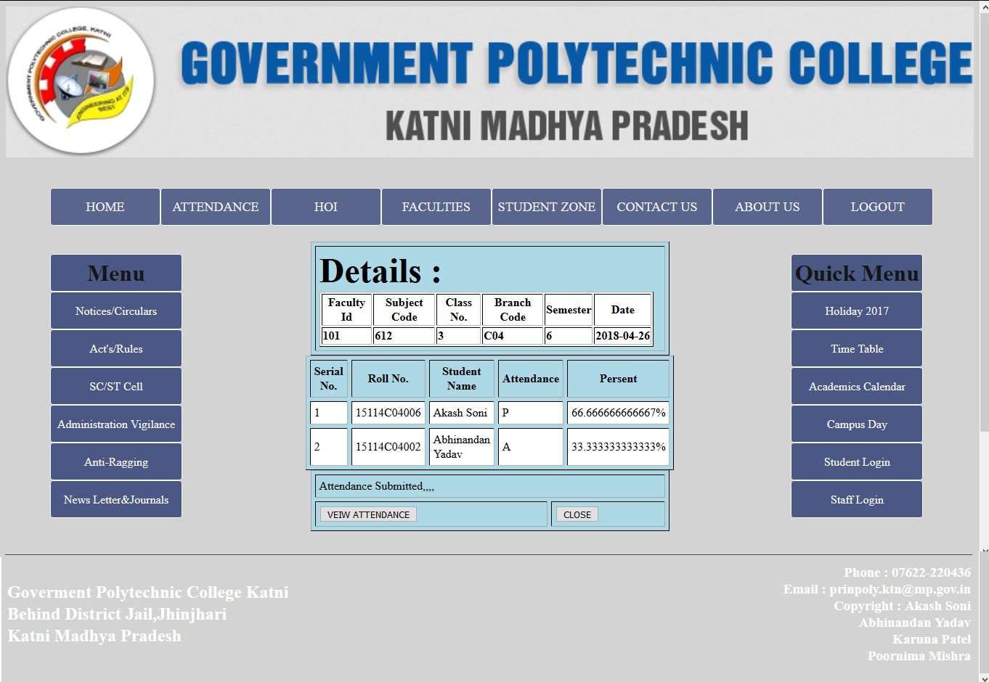

***Fig 10.10***

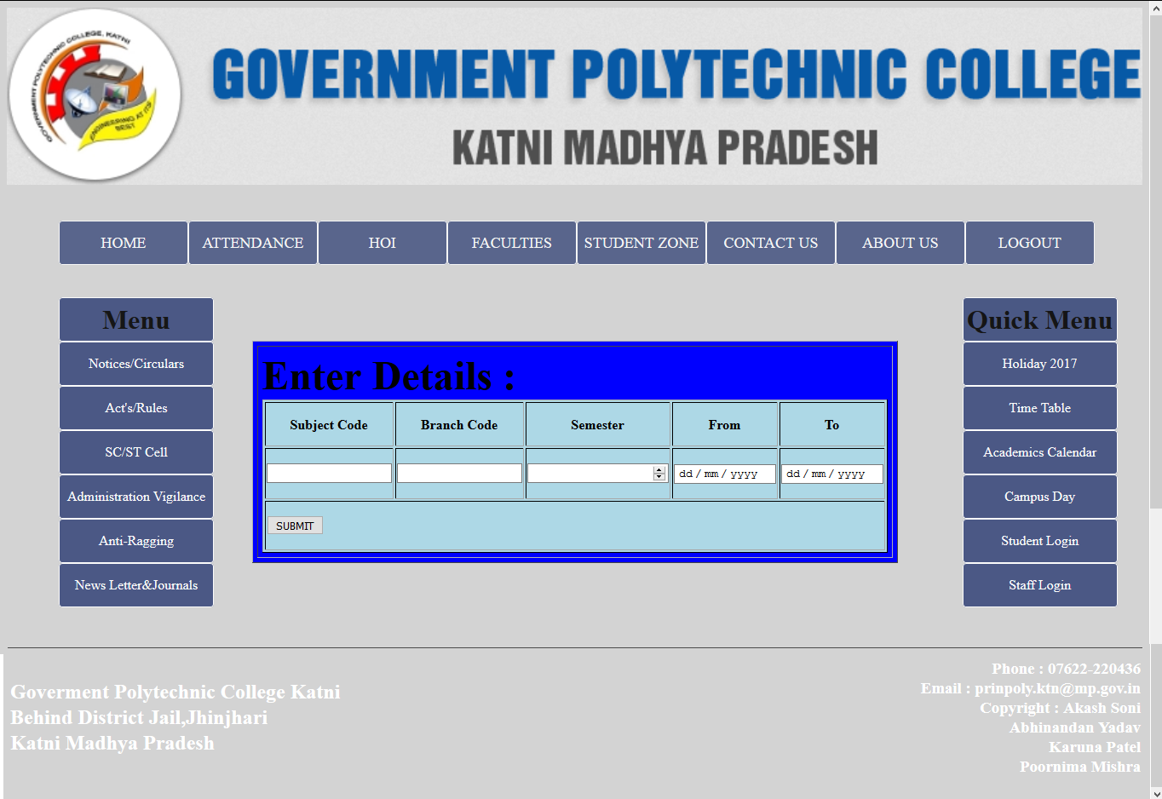

***Fig 10.11***

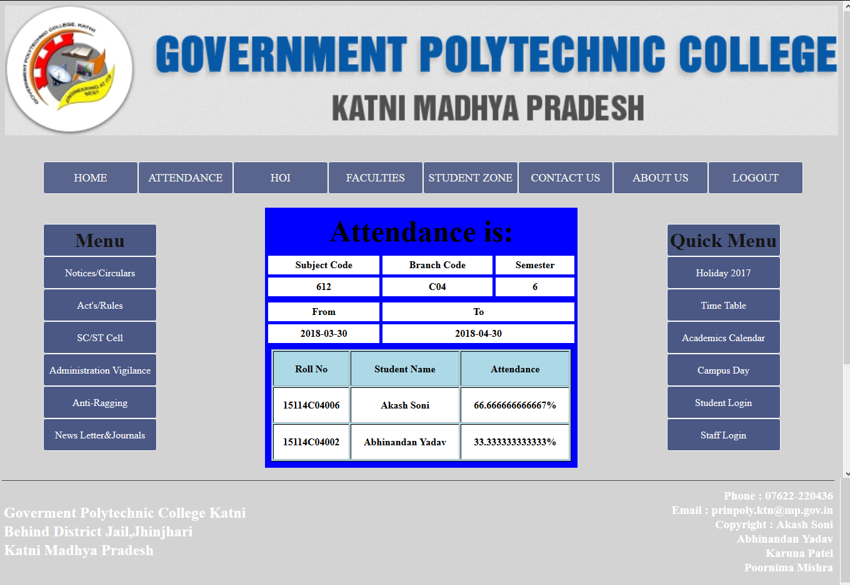

***Fig 10.12***

***4th User Login***

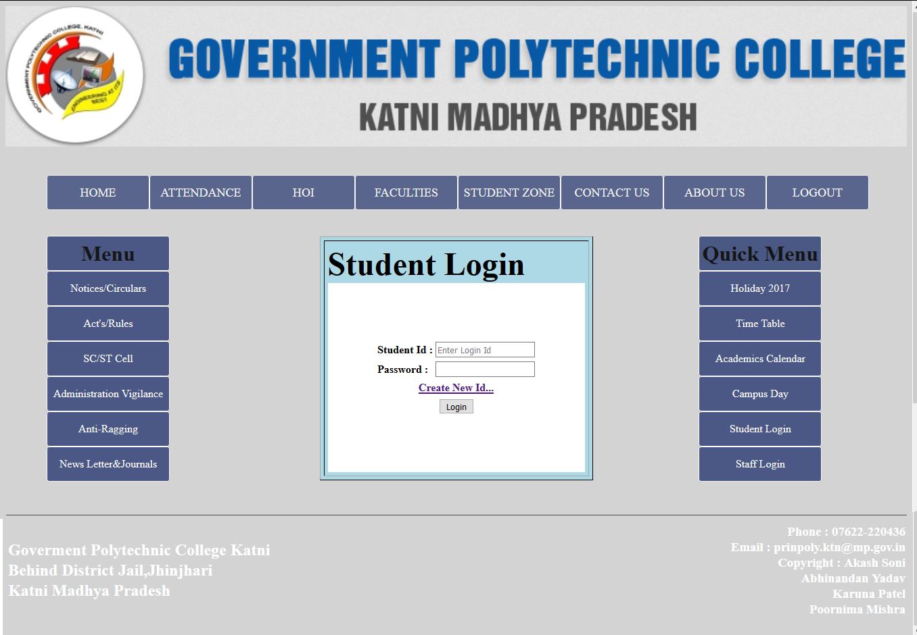

***Fig 10.13***

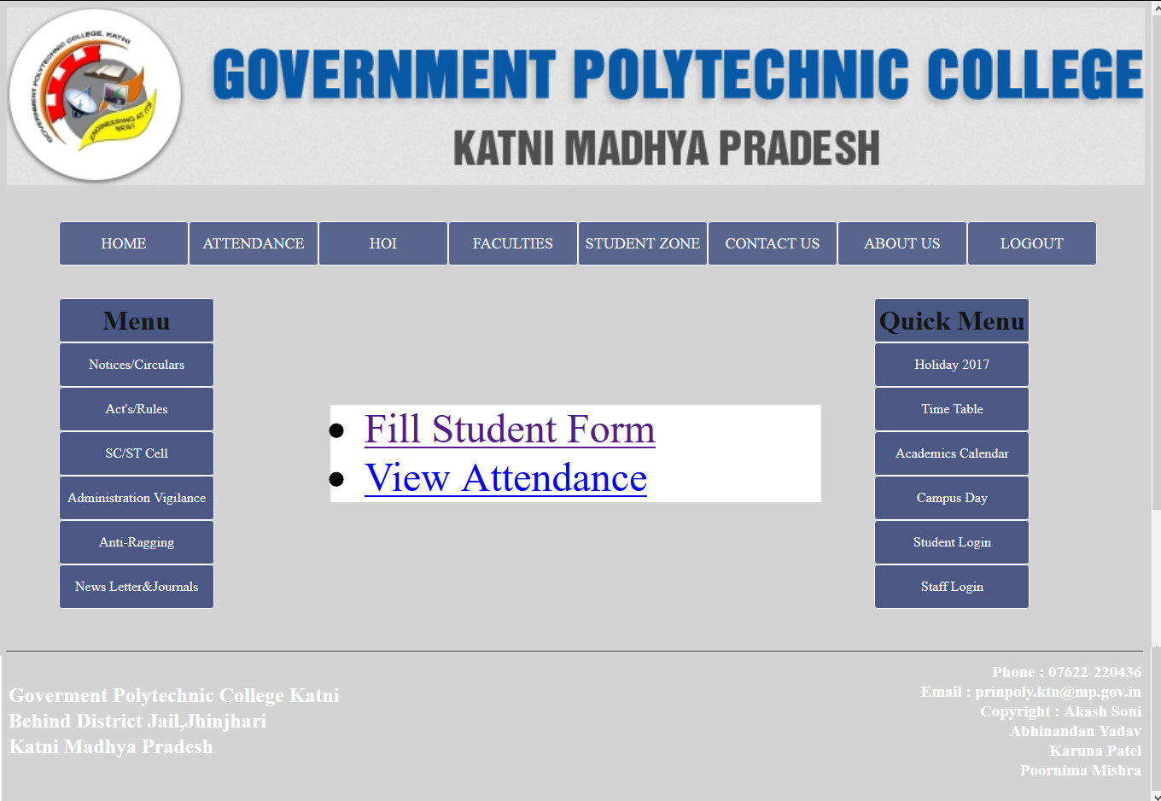

***Fig 10.14***

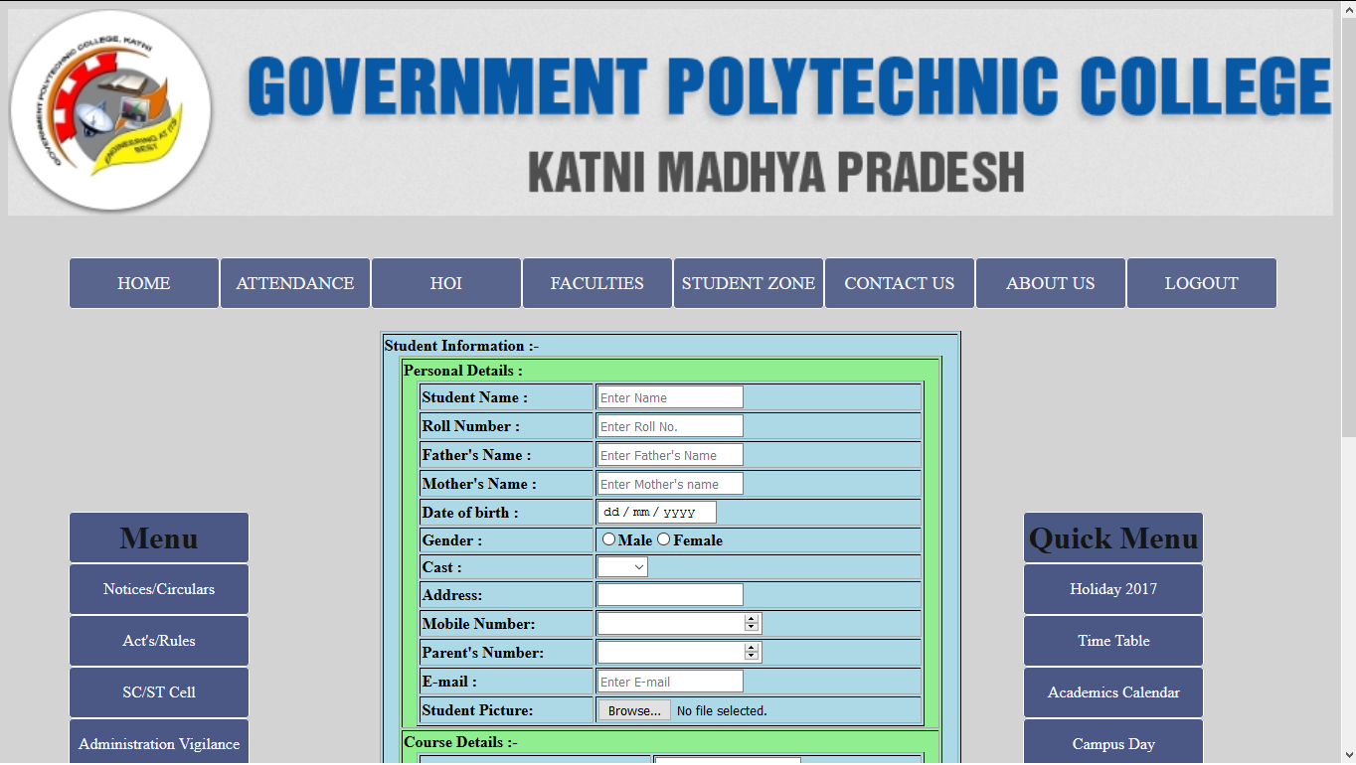

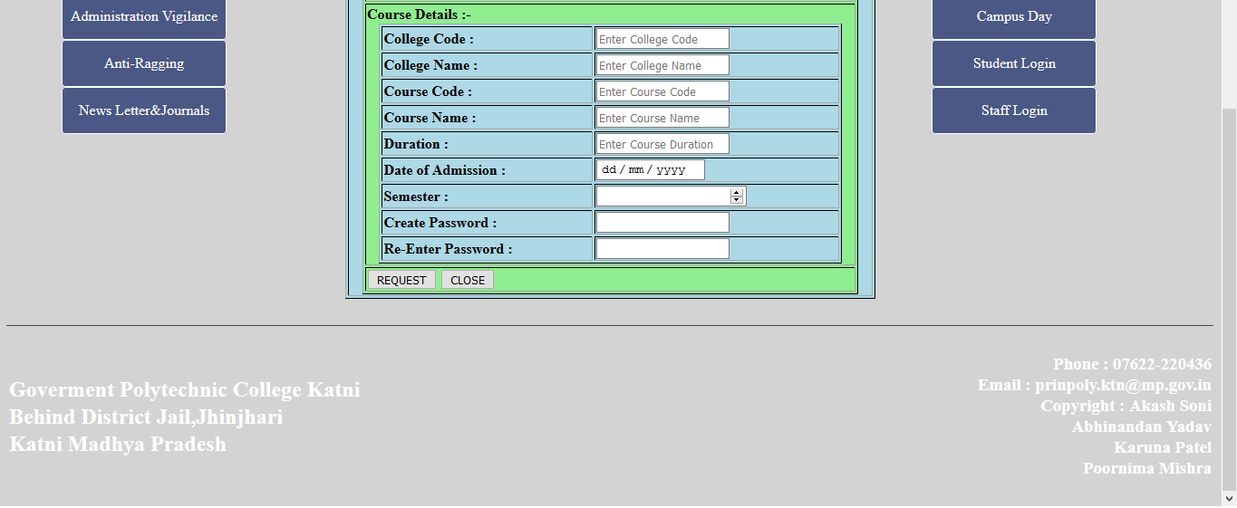

***Fig 10.15***

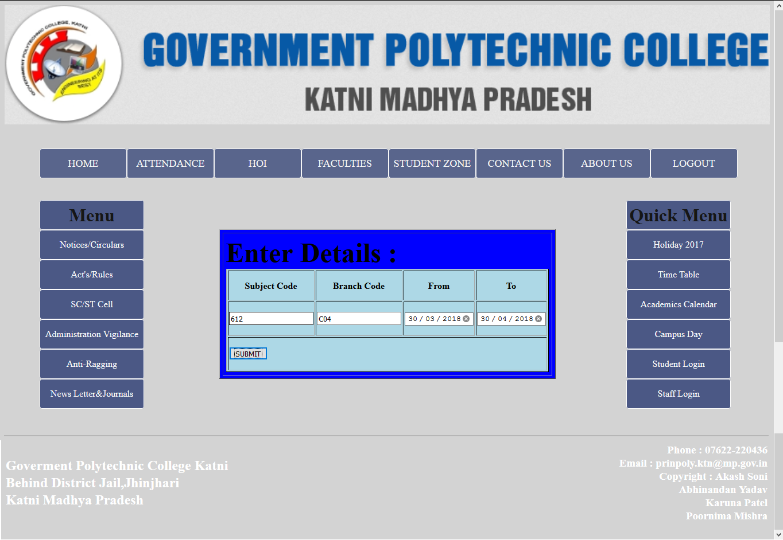

***Fig 10.16***

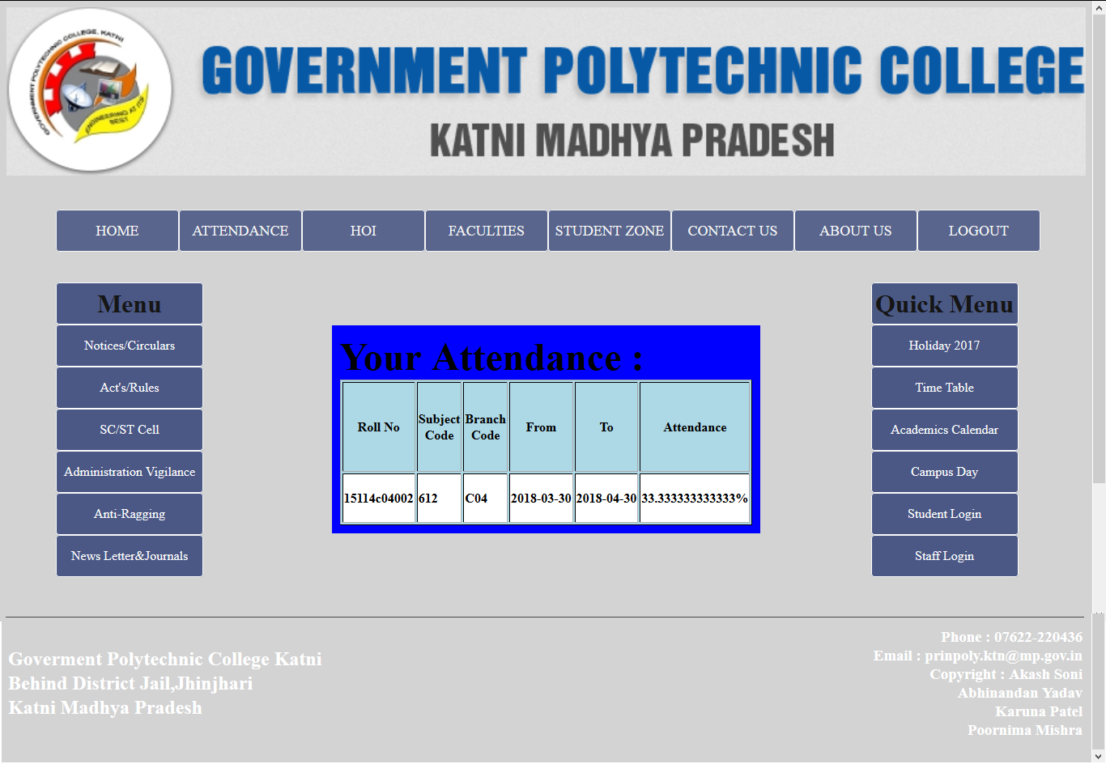

***Fig 10.17***

***5th Create New ID***

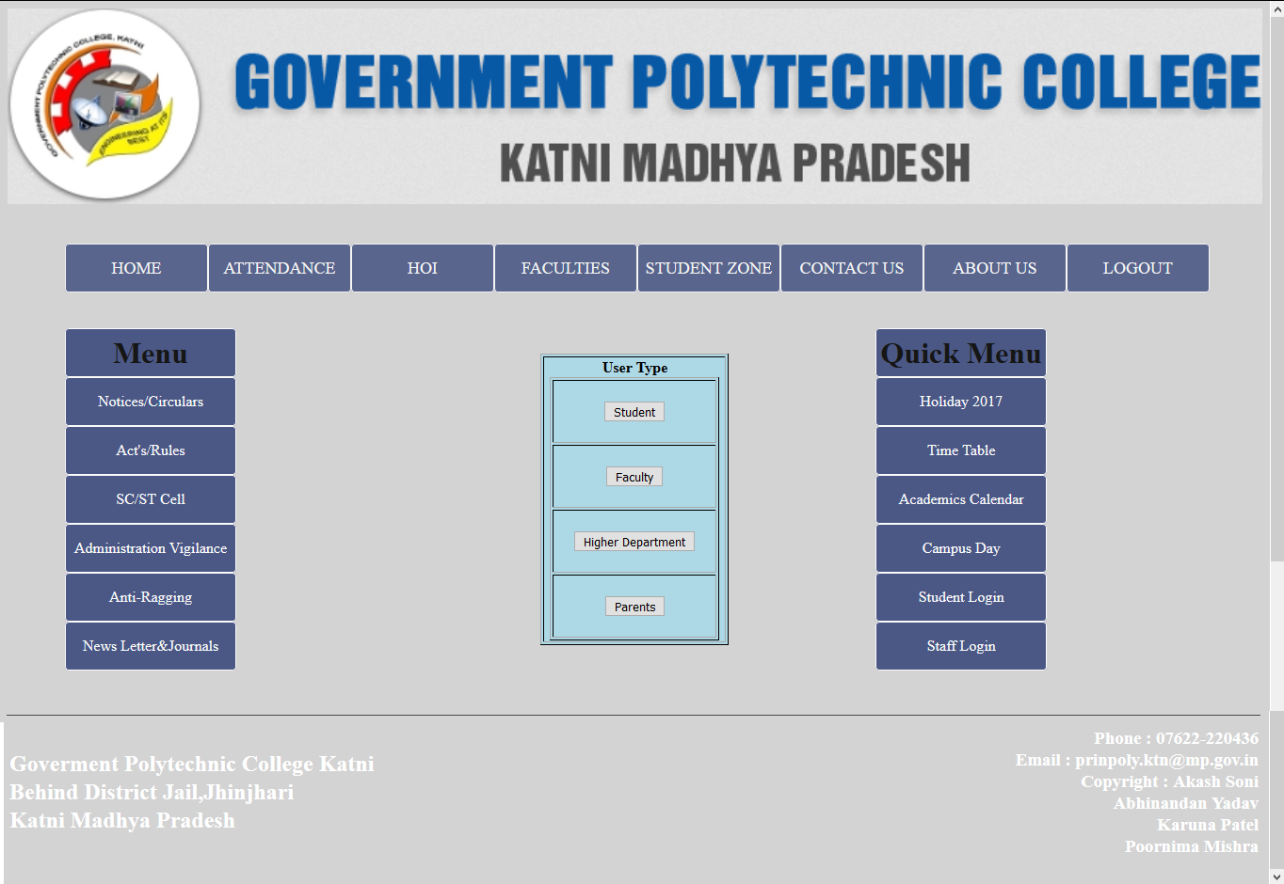

***Fig 10.18***





***Fig 10.19 For Student New Id***

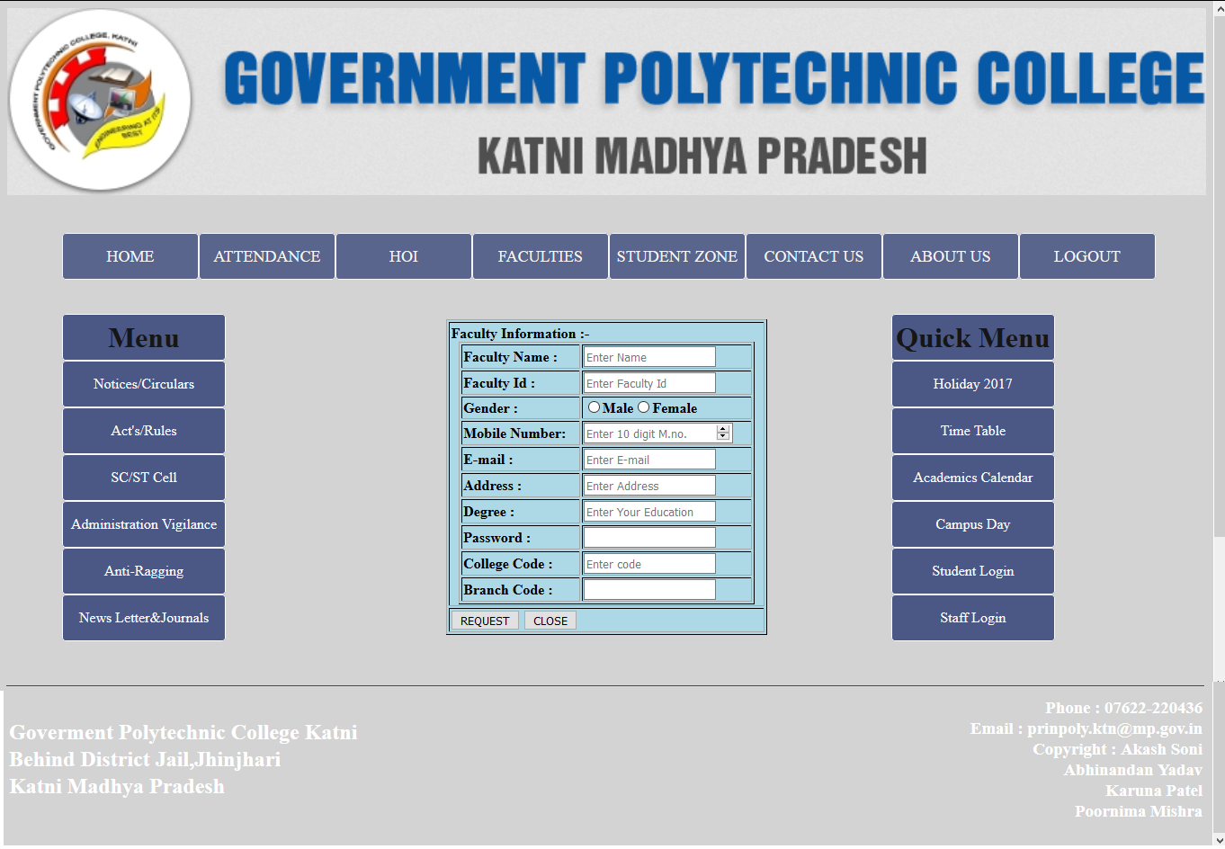

***Fig 10.20 For Faculty New Id***

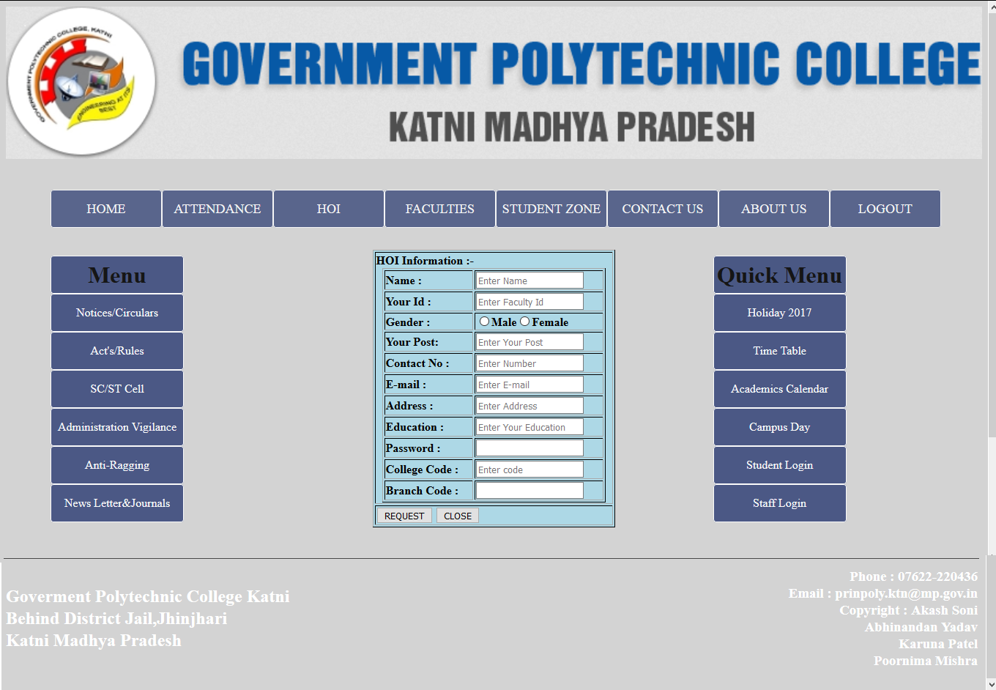

***Fig 10.21 For HOI New Id***

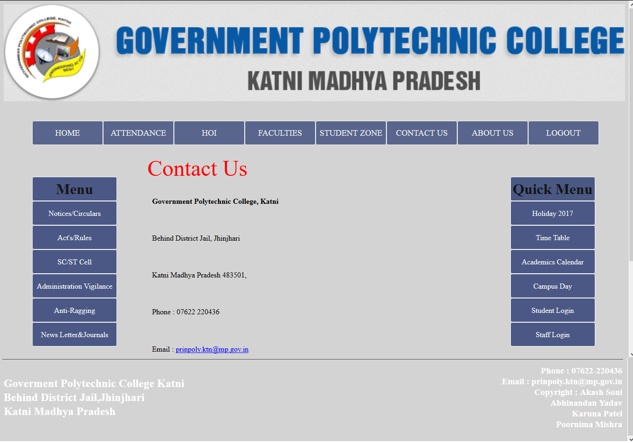

***Fig 10.22 For Contact Us***

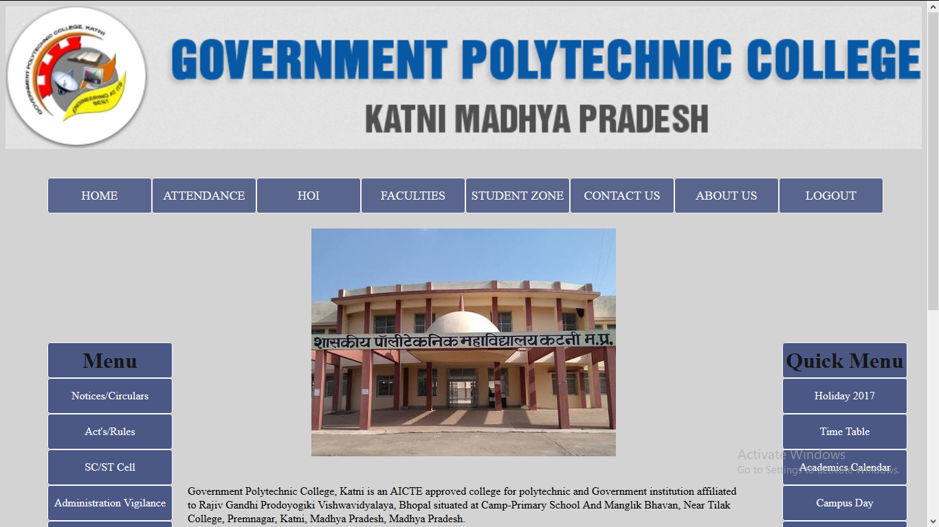

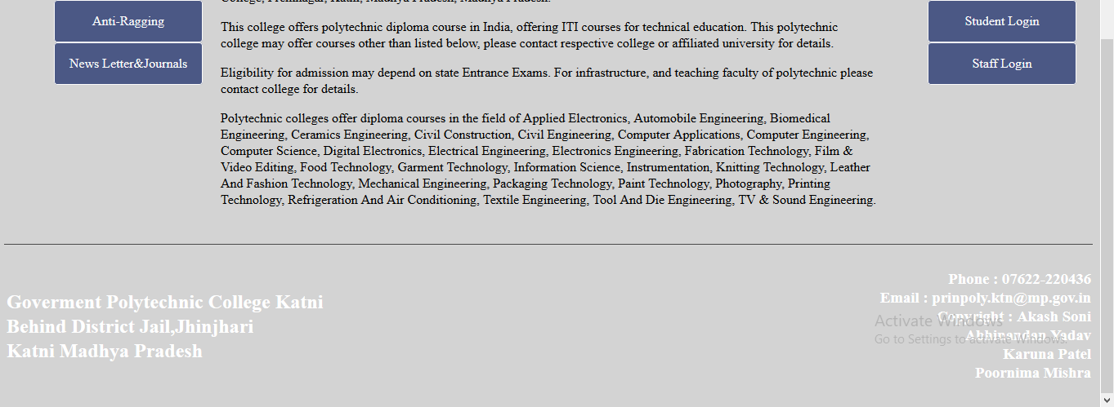

***Fig 10.23 For Aboutus***

***Reference***

* PHP Programming Official Website of PHP ( Oracle )

* Oracle with Develop 2000

By Ivan Bayros

BPB Publication